**DAILY ONLINE ACTIVITIES SUMMARY**

|  |  |  |  |  |  |  |  |  |
| --- | --- | --- | --- | --- | --- | --- | --- | --- |
| **Date:** | **27/6/2020** | | | | | **Name:** | **Nivedita** | |
| **Sem & Sec** | **4th sem/A** | | | | | **USN:** | **4al18cs053** | |
| **Online Test Summary** | | | | | | | | |
| **Subject** | | **DC** | | | | | | |
| **Max. Marks** | | **30** | | **Score** | | | **21** | |
| **Certification Course Summary** | | | | | | | | |
| **Course** | **IOS developer** | | | | | | | |
| **Certificate Provider** | | | **uudemy** | | **Duration** | | | **49 hours** |
| **Coding Challenges** | | | | | | | | |
| **Problem Statement: Write a c++ program to print kth digit** | | | | | | | | |
| **Status: done** | | | | | | | | |
| **Uploaded the report in Github** | | | | | **Yes** | | | |
| **If yes Repository name** | | | | | [**https://github.com/nivi-nivedita/lockdown-coding-program/blob/master/c%2B%2B%20program%20(print%20kth%20value).txt**](https://github.com/nivi-nivedita/lockdown-coding-program/blob/master/c%2B%2B%20program%20(print%20kth%20value).txt) | | | |
| **Uploaded the report in slack** | | | | | **Yes** | | | |

Online Test Details: today I attended dc test at 11:30 for 30 marks and 30 questions.

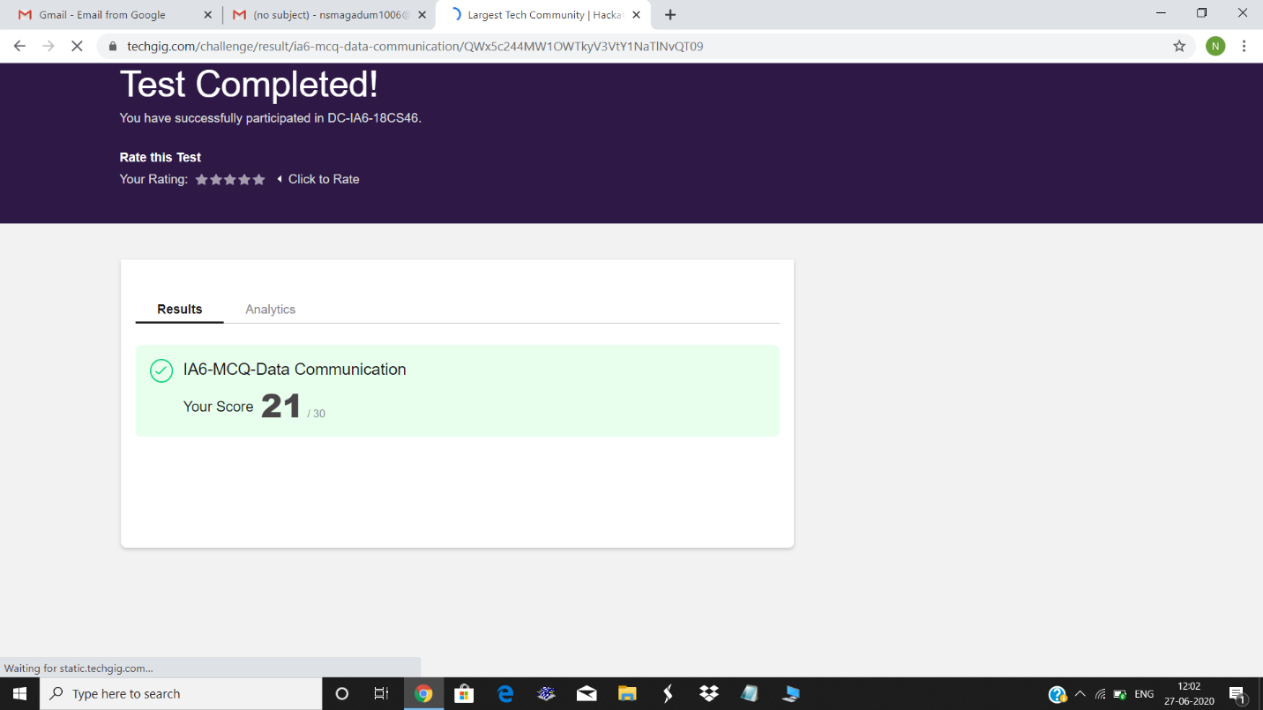

Certification Course Details: I continued same course and completed 4 topics.

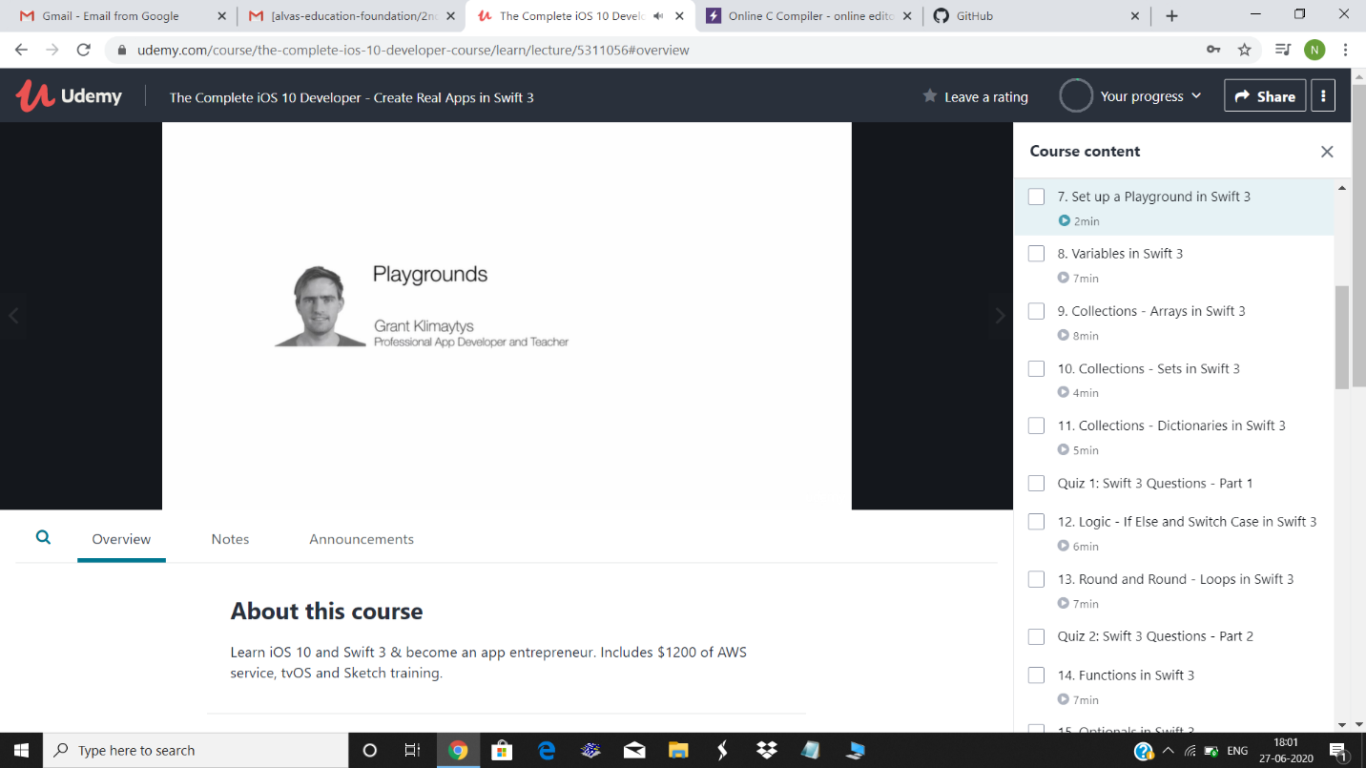

Coding Challenges Details: Write a c++ program to print kth digit.

Executed and uploaded.

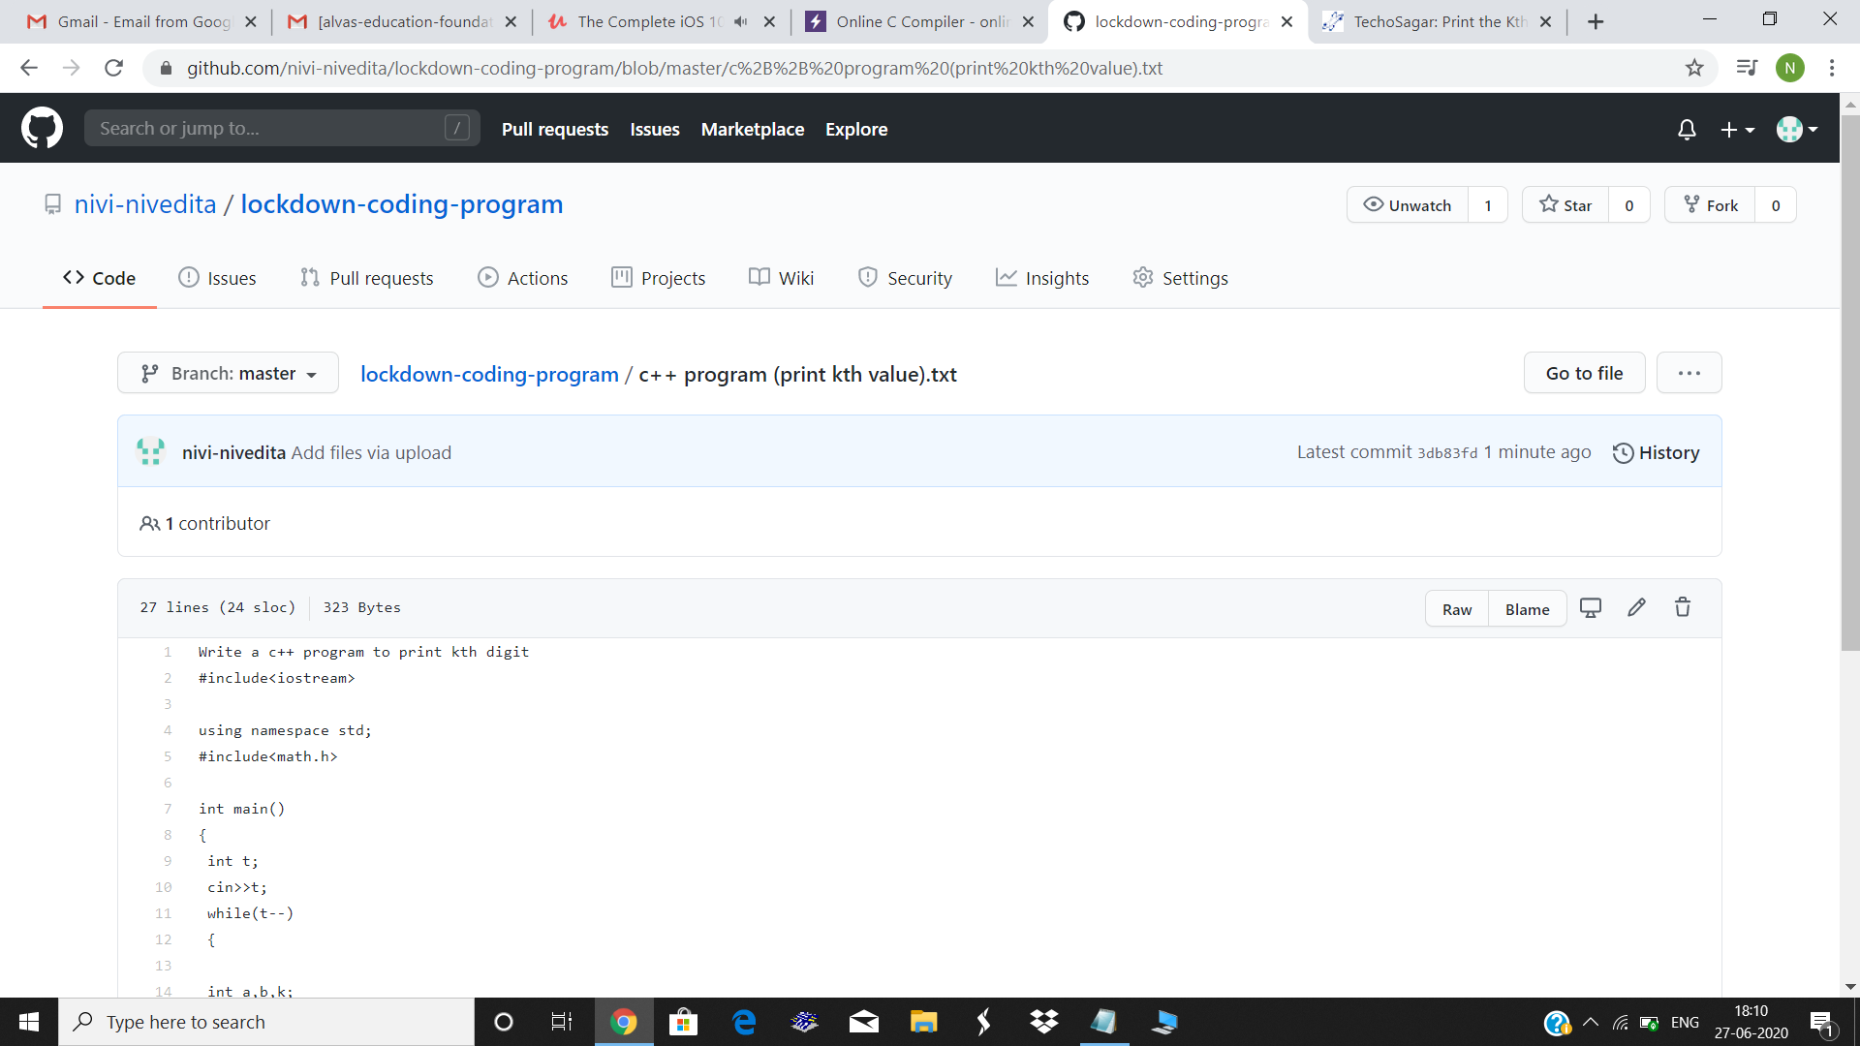

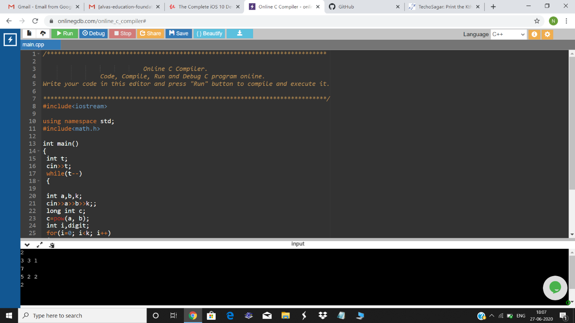

I attended webinar on c++ programing on 2pm(Megha mam)

